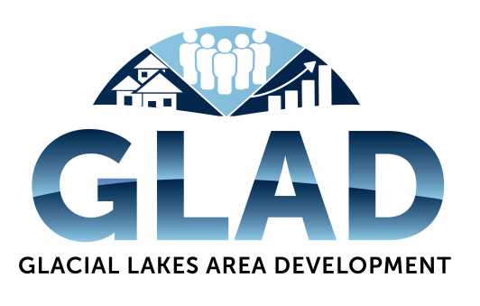

Glacial Lakes Area Development Pledge Form

Name_________________________________________________________________________
Billing Address_________________________________________________________________
City, State, Zip Code_____________________________________________________________
Phone_________________________________________________________________________
Email_________________________________________________________________________

Pledge Information
I (we), ___________________________________, pledge the following amount to Glacial Lakes Area Development:___________________________.
Please check one of the following:
______I am fulfilling the entire pledge at this time.
______I am fulfilling the pledge payable to the following terms:______________________________

Acknowledgement Information
Please use the following name(s) in all acknowledgements:___________________________________
__________________________________________________________________________________

______I (we) wish to have our gift remain anonymous.

Signature______________________________________________________Date__________________

Please make your tax deductible contribution to
Glacial Lakes Area Development (GLAD)
PO Box 231
Britton, SD 57430

Questions may be directed to Lindsey Kimber, Executive Director (GLAD)
605-448-0005
gladsd@venturecomm.net

GLAD is an equal opportunity provider, employer and lender.
If you wish to file a Civil Rights program complaint of discrimination, complete the USDA Program Discrimination Complaint Form, found online at http://www.ascr.usda.gov/complaint_filing_cust.html, or at any USDA office, or call (866) 632-9992 to request the form. You may also write a letter containing all of the information requested in the form. Send your completed complaint form or letter to us by mail at U.S. Department of Agriculture, Director, Office of Adjudication, 1400 Independence Avenue, S.W., Washington, D.C. 20250-9410, by fax (202) 690-7442 or email at program.intake@usda.gov.

